Example usage of SETALLTIMESNOW.zip – to ensure sequential Last Modified time of group of PDF files ingested into Clearwell (this is so that the sort by “Date” in UI will sort as desired).  
  
After extracting the zip somewhere:  
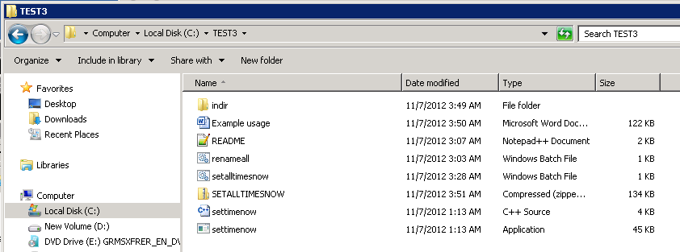  
  
My source files are in the indir directory:  
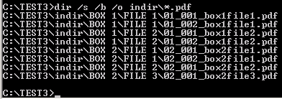  
  
According to the Clearwell de-dup document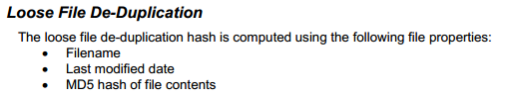  
So, it is therefore safest to rename our documents (if they are already in Clearwell), to avoid any being de-duped. First, create a file containing a sorted list of the file names:  
  
Then run renameall.bat to prepend an extra “0” to each file name:  
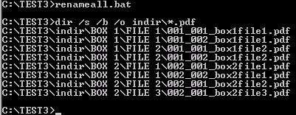  
  
**Note:** We have renamed all the files, so we need to create a new list.txt file:  
  
  
Now we run the setalltimenow.bat script to update the last modified times **in-place**:  
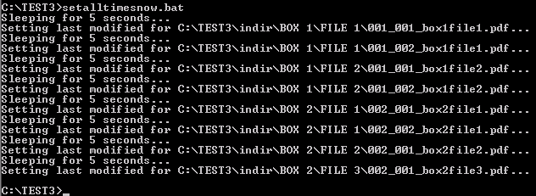  
  
You can now ingest the updated source files into Clearwell. ***Now that you have updated the last modified date, don’t move or copy the files anywhere until they have been ingested into Clearwell.***  
The sort by “Date” column in the UI should now work as desired:  
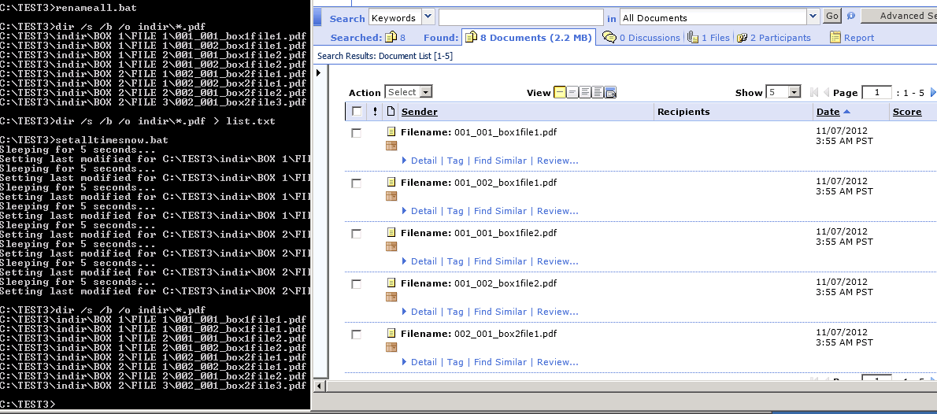  
  
And here is what you will see in a metadata export XML file (where you can see the full resolution of the “DateModified” values):  
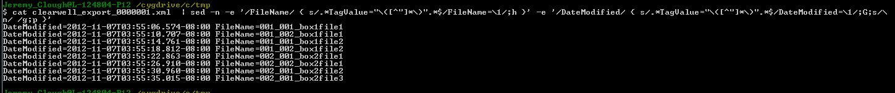  
Note the 4 second or so difference between each file.  
  
END  
7/11/2012